**Lab 1 Logic Gates**

The objective of this lab is to use a Tinkercad breadboard starter kit to test functions of basic logic gates using integrated circuit packages.

1. **Basic Logic Functions and Integrated Circuits**

Digital logic is defined by a two-valued Boolean algebra. There are three basic logic operations: AND, OR, and NOT, that are defined by following truth table with A and B as the inputs and F as the output of the functions. The 1’s and 0’s provide a generic representation of voltage levels in the hardware implementation. The ‘1’ is generally considered to be the high voltage level while the ‘0’ is the low voltage level.

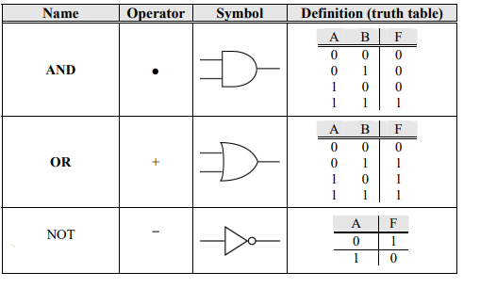

In this experiment you’ll be testing logic functions by assembling hardware circuits using the logic gates. The logic gates are contained in integrated circuits (ICs). Each IC contains several copies of a single type of logic gate. The ICs we are using in the lab are referred to as small scale integration (SSI) ICs because the number of transistors (components used to make logic gates) on each IC is small. The ICs used in lab look nearly the same. It is important to know how to tell them apart and how to locate pin 1. Each IC has a variety of information on its top which can include the manufacturer's name and location, a manufacturer's part number, and date of fabrication as well as the industry standard part number which is the item of primary interest to us. The ICs we will be using belong to families from the 74HTCxx series. The following figure shows common ways of designating pin 1. Sometimes a notch is present, sometimes a dot, and sometimes both. In constructing circuits, wiring errors can be reduced and debugging aided by orienting the ICs in the same direction on the breadboard.

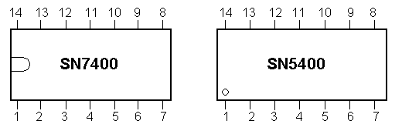

Figure 1. Two ways of identifying pin 1.

1. **Implementing and testing logic gates using a Tinkercad Starter Kit**

In this experiment, you’ll test three IC chips shown in Figure 2.

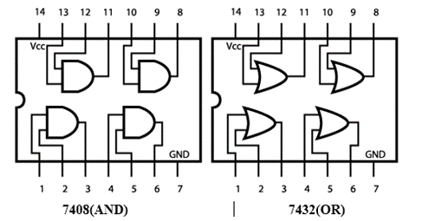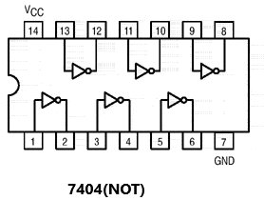

Figure 2. 74HC**08** Quad AND gate, 74HCT**32** Quad OR gate, 74HCT**04** inverter gate

The procedure can be divided into the three steps listed below.

1. Place your IC on the breadboard.

2. Add power and ground (Vcc and GND) to your circuit.

3. Add the required connections to and from switches/LEDs for the input and output signals.

**Procedure:**

1. Log into the Tinkercad, copy and paste the following link to your web browser <https://www.tinkercad.com/things/19XqriP2dMF> . Click on the button of “Copy and Tinker” on the right to make a copy of the CSC 347 starter circuit as below.

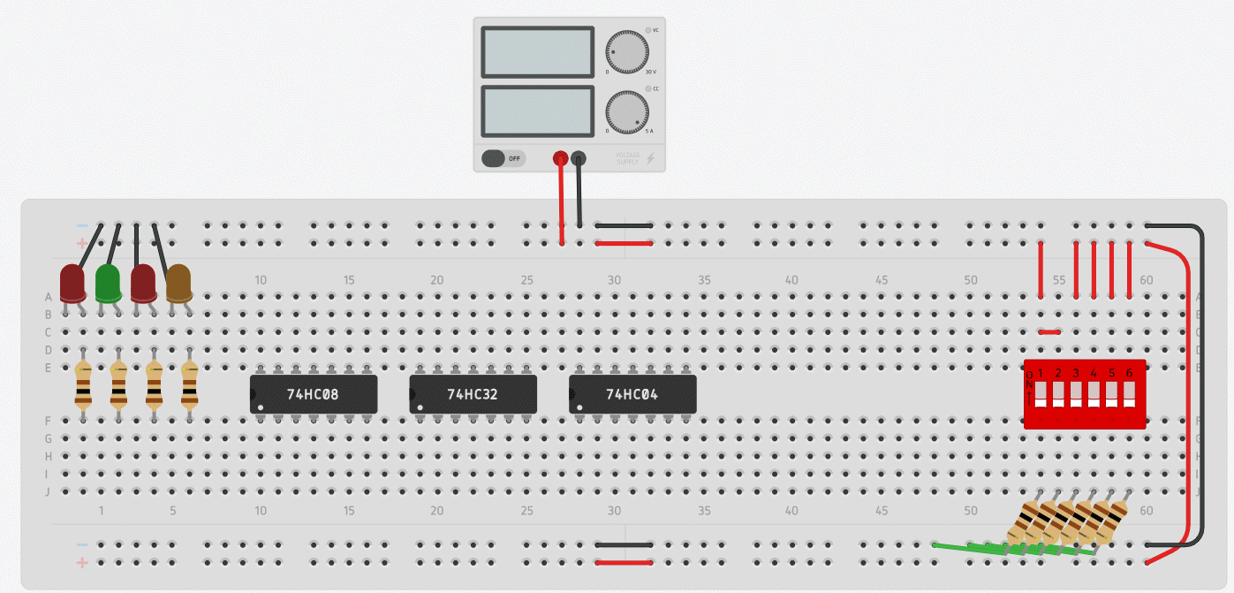

We will use the above starter kit to build and test circuits. Note that **You can only use holes in the lower half of the breadboard for LEDs and Switches**.

1. Place the following 3 chips 74HC08, 74HC32, 74HC04 in the middle of the breadboard.
2. Connect the (7408, 7432, 7404) chips’ pin 14 to the +5v power (+), and pin 7 to ground (-).
3. Locate the inverter **chip 74HC04**. Connect pin 1 to a logic switch and pin 2 to a logic indicator (LED). Click on the “Start Simulation” button at the top right corner. Use the logic switch to alternately apply 1s and 0s to the inverter, and record the output logic levels in the table. Verify that the output is the complement of the input. Click on the “Stop Simulation” when you are done.

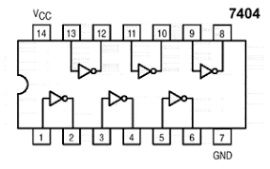

|  |  |
| --- | --- |
| Pin 1 | Pin 2 |
| 0 |  |
| 1 |  |



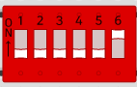

1. Locate AND gate **chip 74HC08**. Connect pin 1 to a logic switch, pin 2 to another logic switch, and pin 3 to a logic indicator (LED). Click on the “Start Simulation” button. Use logic switches to apply the logic levels 0 and 1 to gate inputs (pin 1, pin2), and record the output logic levels in the table. Click on the “Stop Simulation” when you are done. Verify that the table is the same as the truth table for AND operation.

|  |  |  |
| --- | --- | --- |
| Pin 1 | Pin 2 | Pin 3 |
| 0 | 0 |  |
| 0 | 1 |  |
| 1 | 0 |  |
| 1 | 1 |  |

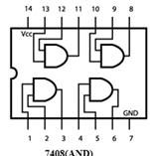







1. Locate OR gate **chip 74HC32**. Connect pin 1 to a logic switch, pin 2 to another logic switch, and pin 3 to a logic indicator. Click on the “Start Simulation” button. Use logic switches to apply the logic levels 0 and 1 to gate inputs (pin 1, pin2), and record the output logic levels in the table. Click on the “Stop Simulation” when you are done. Verify that the table is the same as the truth table for OR operation.

|  |  |  |
| --- | --- | --- |
| Pin 1 | Pin 2 | Pin 3 |
| 0 | 0 |  |
| 0 | 1 |  |
| 1 | 0 |  |
| 1 | 1 |  |

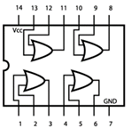







1. Test another OR gate in the chip 74HC32: connect pin 10 to a logic switch, pin 9 to another logic switch, and pin 8 to a logic indicator. Click on the “Start Simulation” button. Use logic switches to apply the logic levels 0 and 1 to gate inputs (pin 10, pin 9), and record the output logic levels in the table. Click on the “Stop Simulation” when you are done. Verify that the table is the same as the truth table for OR operation.







|  |  |  |
| --- | --- | --- |
| Pin 10 | Pin 9 | Pin 8 |
| 0 | 0 |  |
| 0 | 1 |  |
| 1 | 0 |  |
| 1 | 1 |  |



1. Build a circuit to implement the Boolean function F = x + y’z using 3 basic logic gates and record the value of y’z (use an LED output) and the output F in the table. Verify the correctness of the table.

|  |  |  |  |  |
| --- | --- | --- | --- | --- |
| x | y | z | y’z | F |
| 0 | 0 | 0 |  |  |
| 0 | 0 | 1 |  |  |
| 0 | 1 | 0 |  |  |
| 0 | 1 | 1 |  |  |
| 1 | 0 | 0 |  |  |
| 1 | 0 | 1 |  |  |
| 1 | 1 | 0 |  |  |
| 1 | 1 | 1 |  |  |

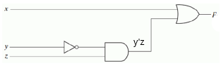

**Submission Instructions:**

Lab work submission

1. Take a screenshot of your circuit in Step 8) by clicking on “Share” ->”Snapshot of your design” at the top right corner.
2. Copy the link of your circuit for sharing (click on “Share” -> “Invite people” ->”Copy”)
3. On the Blackboard, click on Lab 1. Attach the screenshot from Step 1, this file with the completed tables, and paste the link from Step 2 into the Comments area, then hit Submit button.

Lab report submission: no report is needed for this lab.